**Experiment No. 10**

Title: Implementing and Using Sample Cloud Services with Microsoft Azure

**Objective:**

To implement and utilize sample cloud services provided by Microsoft Azure, exploring functionalities and capabilities within the Azure cloud platform.

**Tools used:**

- Microsoft Azure Portal

**Prerequisite:**

- An active Microsoft Azure account with necessary permissions and access

- Basic understanding of cloud computing concepts

**Steps:**

**Step 1.** Access Azure Portal

- Log in to the Azure Portal using your Azure account credentials <https://azure.microsoft.com/en-in>

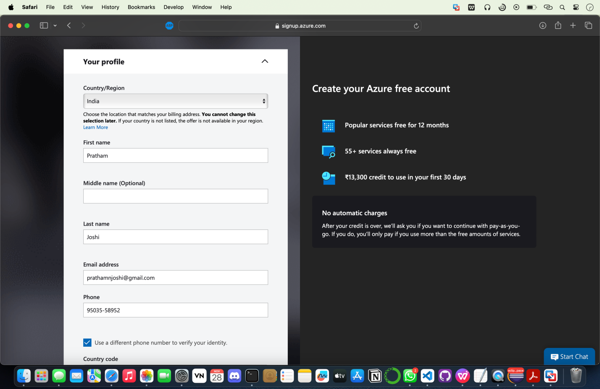

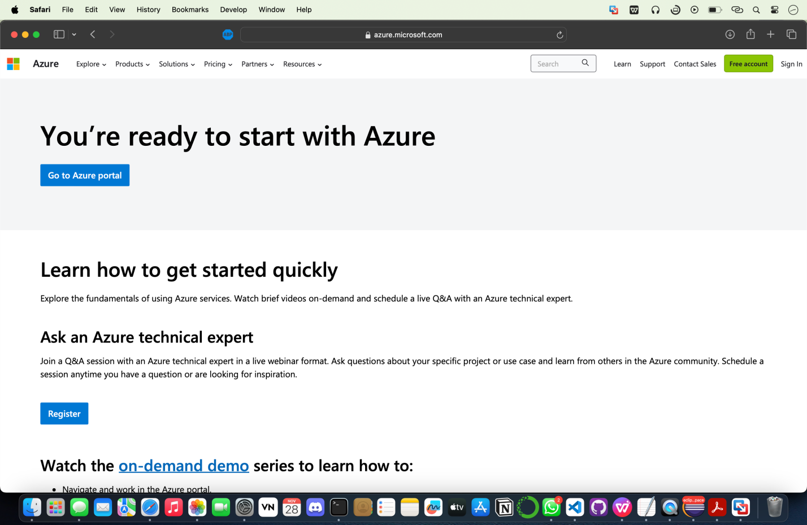

**Step 2.** Explore Azure Services

- Navigate through the Azure Portal to discover various services offered.

- Identify sample cloud services such as Azure Virtual Machines, Azure Storage, Azure App Services, etc.

**Step 3.** Create and Deploy Sample Service

- Choose a sample service (e.g., Azure Virtual Machine).

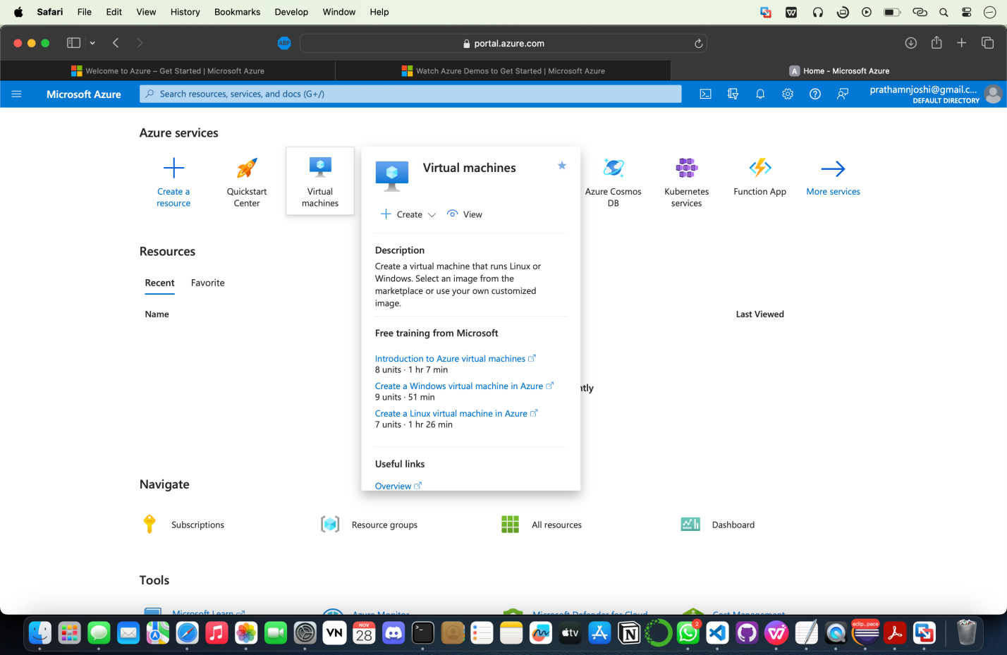

- Follow the Azure interface to create and deploy the selected service.

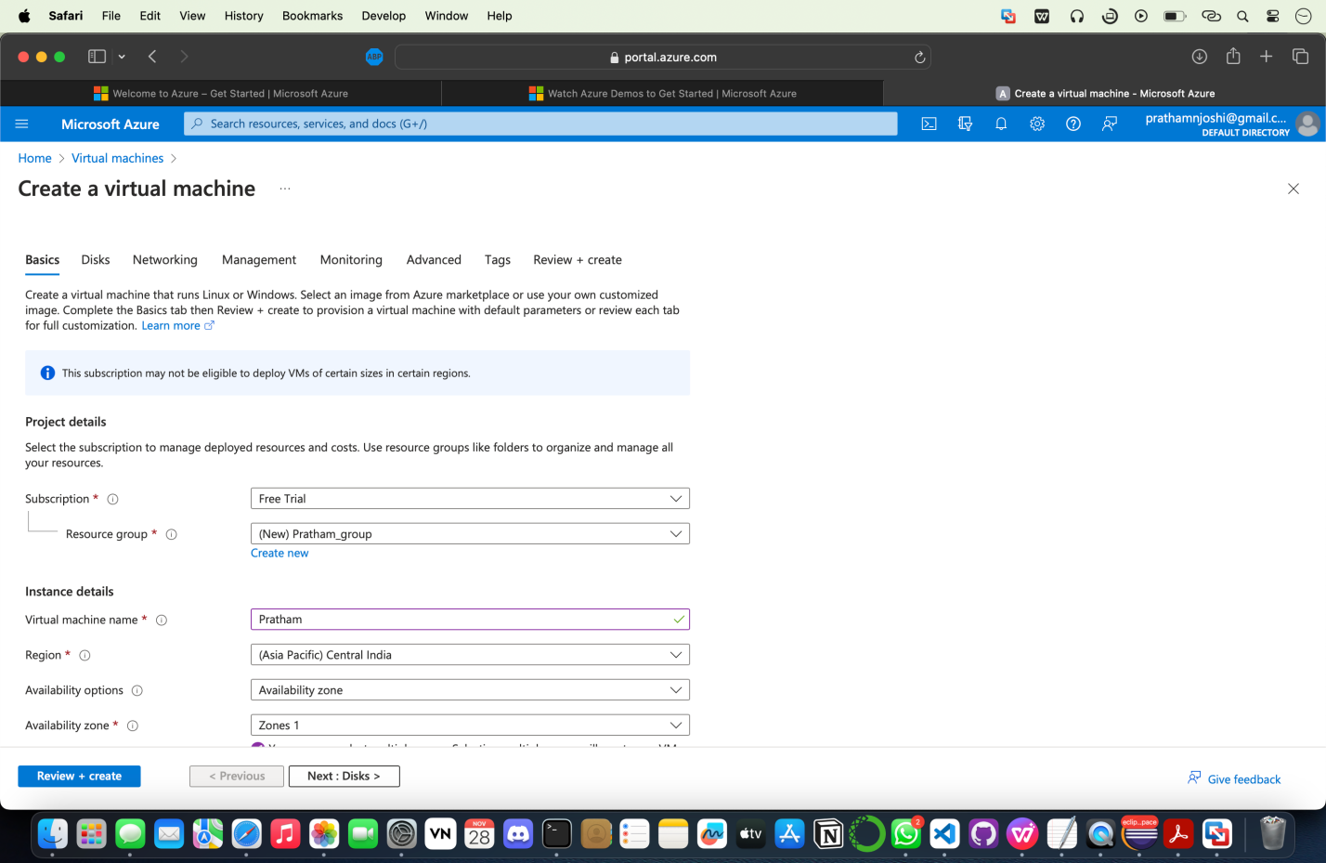

- Configure settings as required during the creation process.

**Step** 4. Utilize the Service

- Access and interact with the deployed service to understand its functionalities.

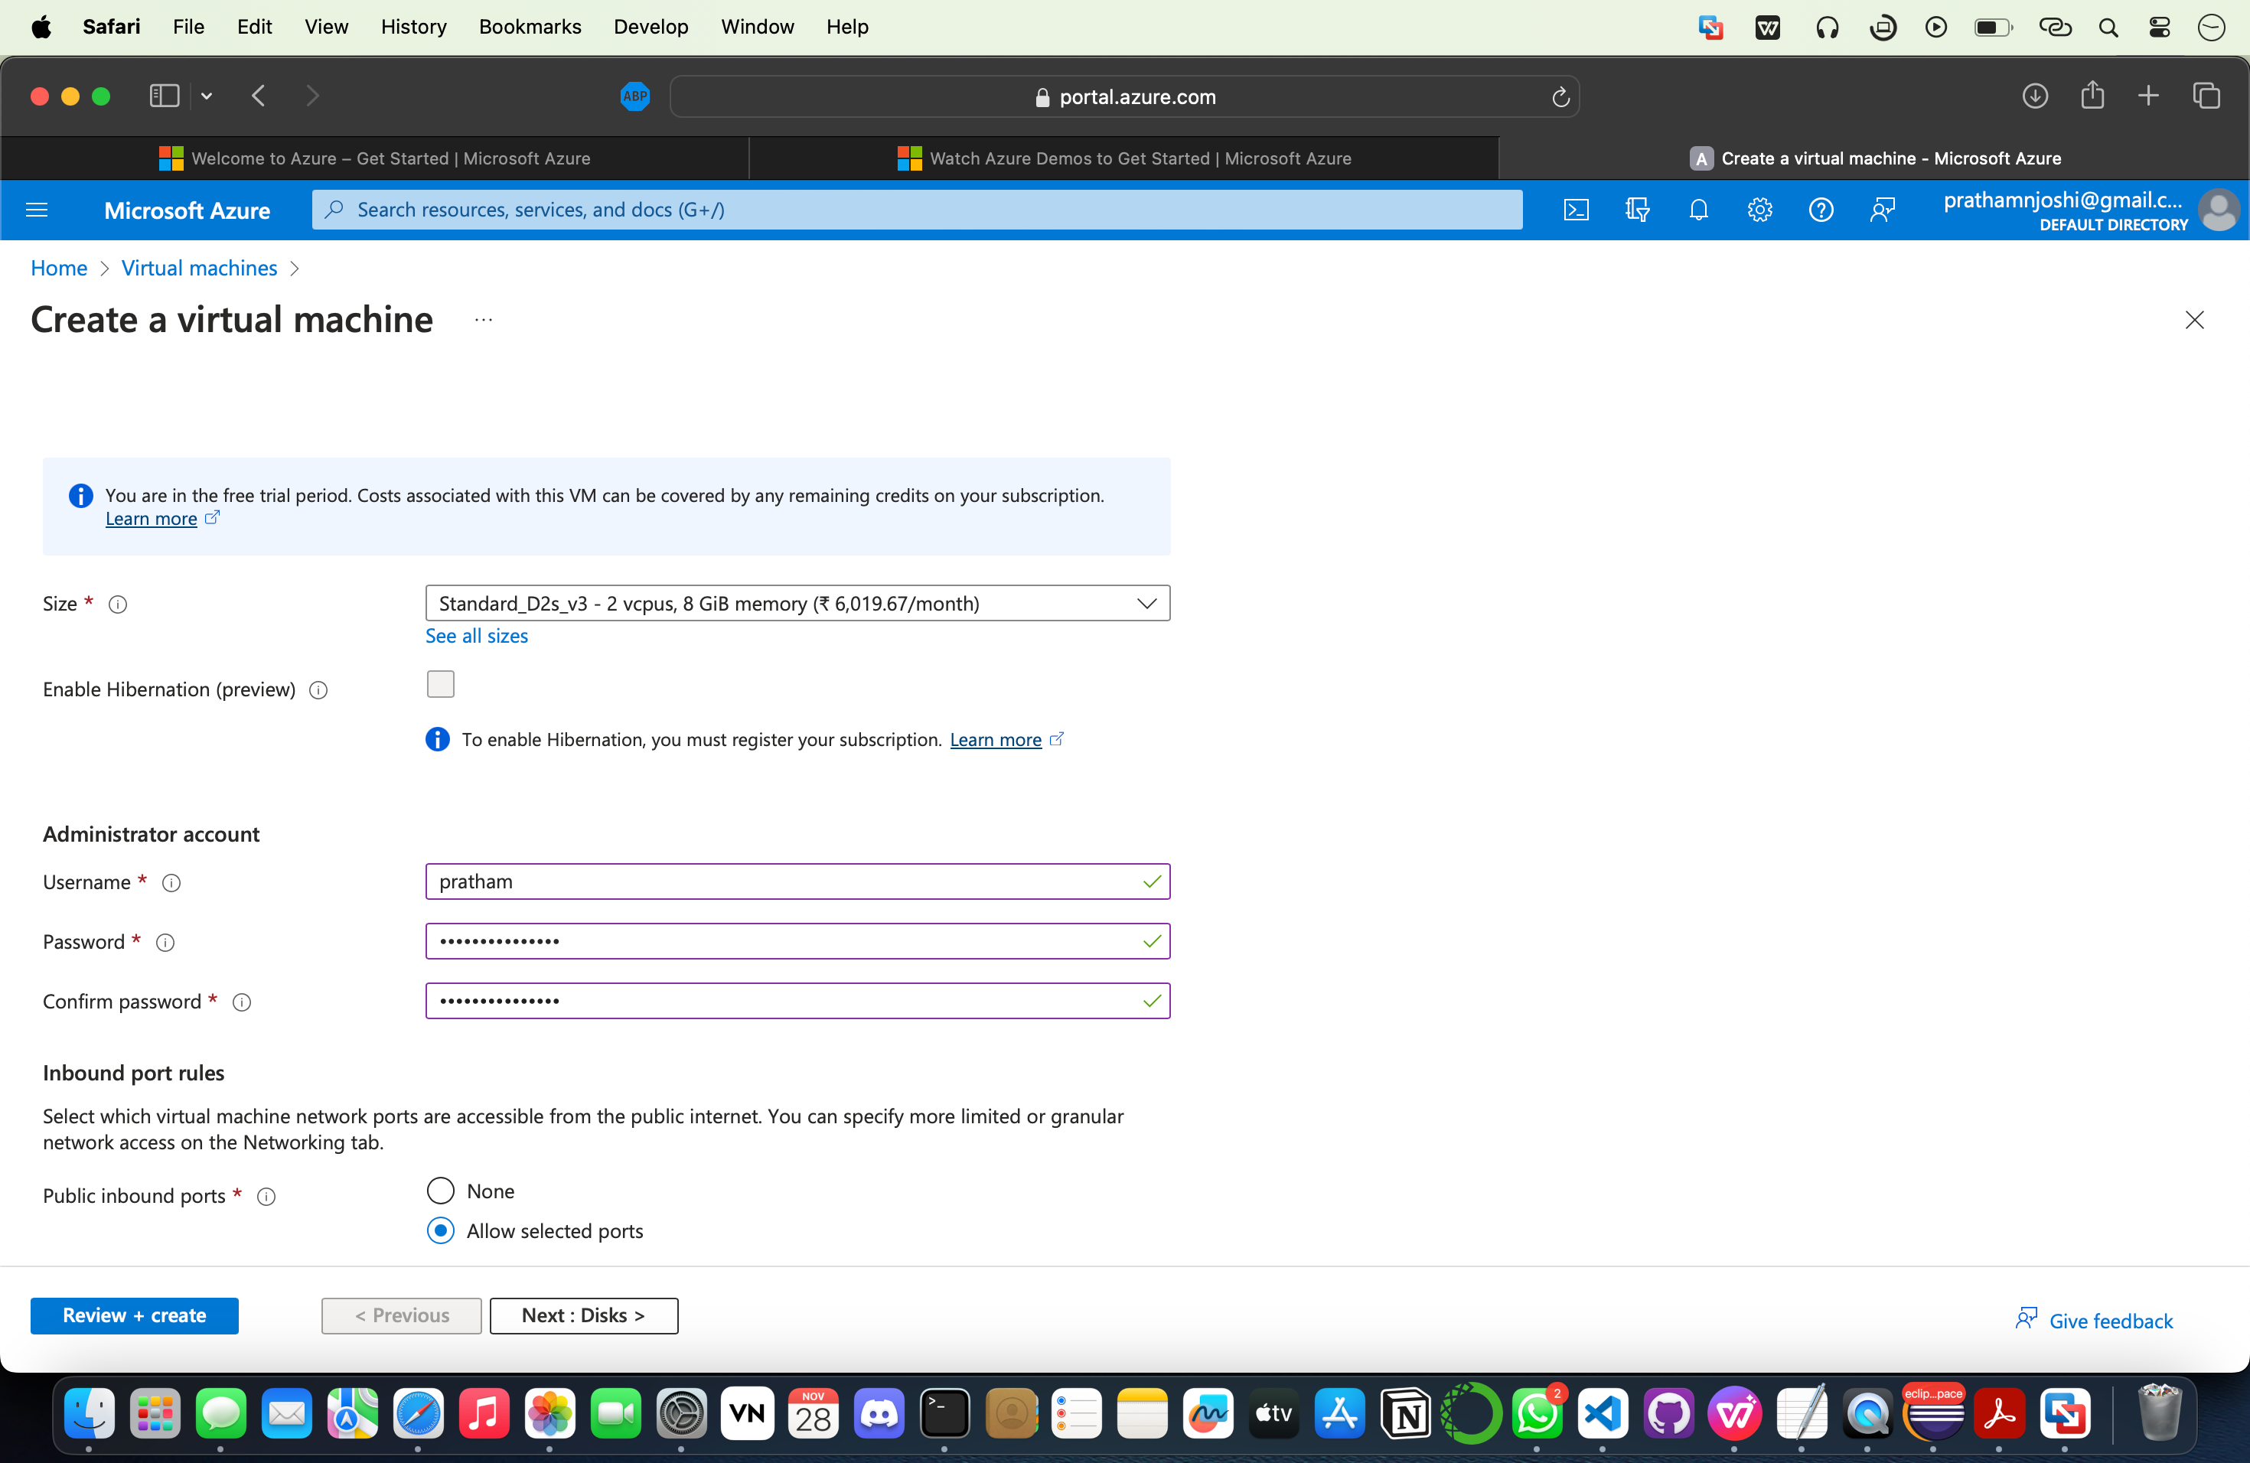

- Experiment with features like scalability, management, and monitoring provided by Azure.

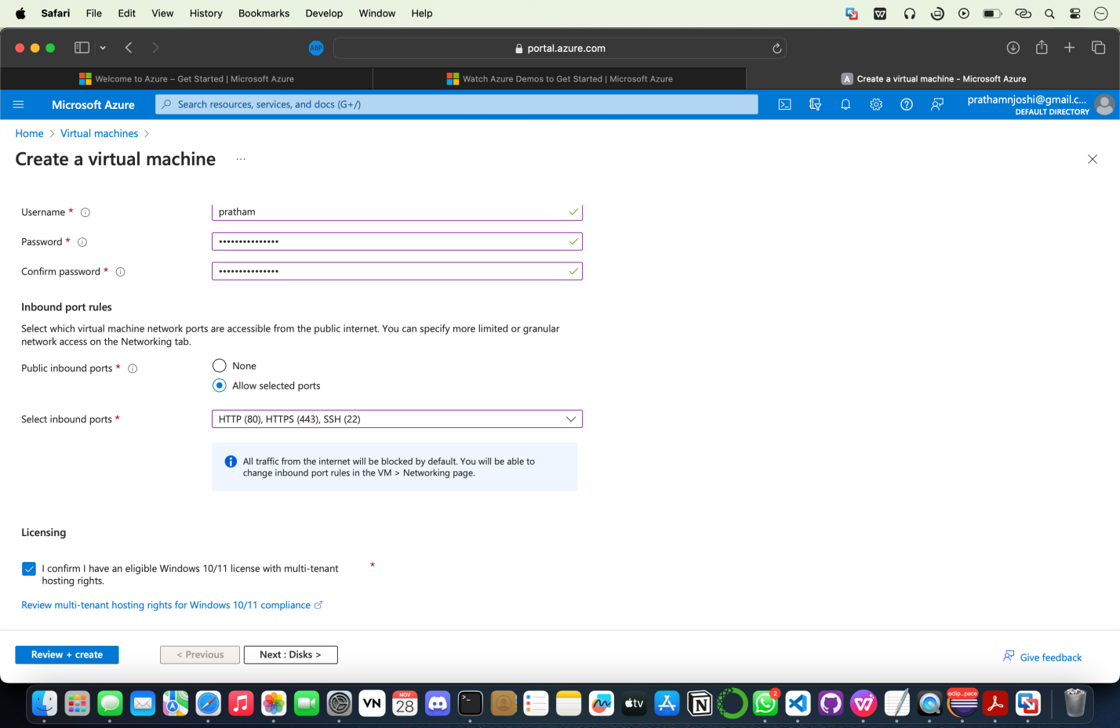 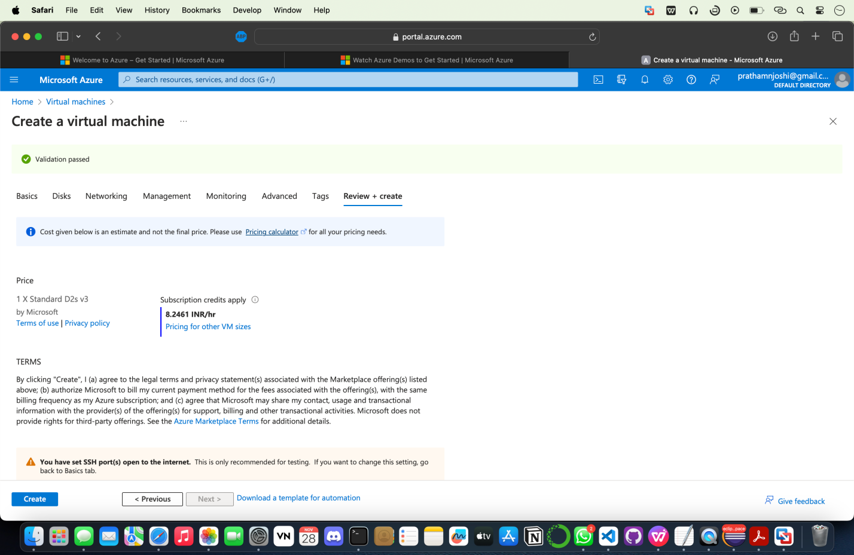

**Step** 5. Explore Integration

- Investigate how different Azure services can be integrated to create comprehensive cloud solutions.

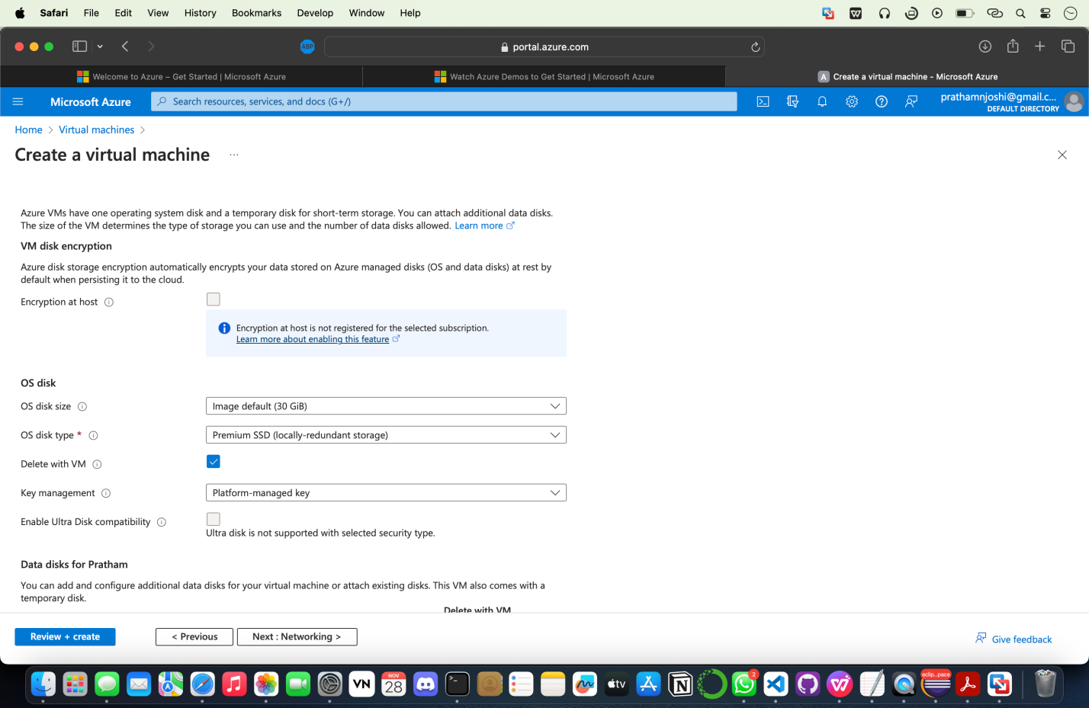

- Understand how Azure resources can interact with each other within the Azure environment.

**Step** 6. Experiment and Learn

- Experimented with other sample services available in Azure to gain familiarity with the diverse capabilities of the platform.

**Conclusion:**

Successfully implemented and utilized sample cloud services within Microsoft Azure, gaining insights into the functionalities and capabilities offered by the Azure cloud platform.